MSL Quick Guide – Recording Voice and Audio Playback (Mac)
Firstly, in order to successfully use MySpanishLab with a Mac, you must use Safari as your web browser.
Once you have updated all applications through the Browser Tune-up, you may notice that the Wimba Voice Set-up Wizard will not run correctly. Do not worry, the recording and audio playback will still work.
1. If you select an activity that runs the Java plug-in, you may see this message when you click record/play:
To correct this, simply click on the text “Inactive Plug-in”
2. You will then see this notice:
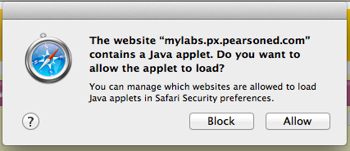
3. Click “Allow” and then scroll down and click “Record” or “Play” again.

4. You will then see this message:
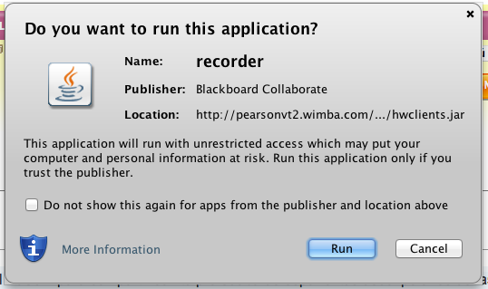
5. Click on the check box “Do not show this again…” then click “Run”
6. Finally, click the record or play button one more time and the plug-in should run correctly.

